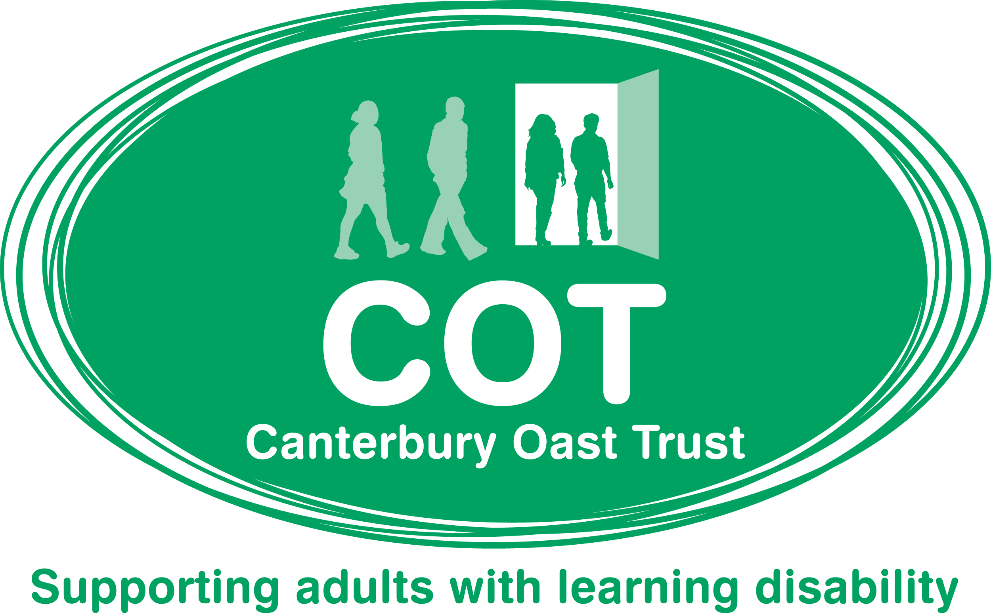
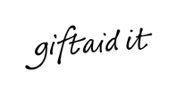

Gift Aid allows our charity to reclaim the basic rate of income tax you have paid on your donation. If you are a UK taxpayer using Gift Aid means that for every pound that you give us we reclaim the standard Gift Aid of 25p for every pound donated.

Tell us you want to Gift Aid your donation, we will do the rest.

GIFT AID DECLARATION – for past, present and future donations.

I would like to make a donation to Canterbury Oast Trust using Gift Aid.
Title: | Forename(s): | Surname:
Address:
Postcode:
Telephone:

Please treat as Gift Aid donations all qualifying gifts of money made:
Today in the past 4 years in the future
Please tick all boxes you wish to apply.

I confirm I have paid or will pay an amount of Income Tax and/or Capital Gains Tax for each tax year (6 April to 5 April) that is at least equal to the amount of tax that all the charities or Community Amateur Sports Clubs (CASCs) that I donate to will reclaim on my gifts for that tax year. I understand that other taxes such as VAT and Council Tax do not qualify. I understand the charity will reclaim 28p of tax on every £1 that I gave up to 5 April 2008 and will reclaim 25p of tax on every £1 that I give on or after 6 April 2008.

Signed: | Date:

Please notify us if you:
- Want to cancel this declaration
- If you change your name and/or address
- No longer pay sufficient tax on your income and/or capital gains
- If you pay Income Tax at the higher rate or additional rate and want to receive the additional tax relief due to you, you must include all your Gift Aid donations on your Self Assessment tax return or ask HM Revenue and Customs to adjust your tax code.

Please return this form to:

The Fundraising Department
Canterbury Oast Trust, Highlands Farm, Woodchurch, Kent, TN26 3RJ

Tel: 01233 860806, Email: fundraising@c-o-t.org.uk, Website: www.c-o-t.org.uk
Registered Charity Number: 291662 Registered Company: 1897198

